1.Users table
CREATE TABLE Users (
user_id INT AUTO_INCREMENT PRIMARY KEY,
full_name VARCHAR(100) NOT NULL,
email VARCHAR(100) UNIQUE NOT NULL,
city VARCHAR(100) NOT NULL,
registration_date DATE NOT NULL
);
To insert the sample data:
INSERT INTO Users (full_name, email, city, registration_date)
VALUES
('Alice Johnson', 'alice@example.com', 'New York', '2024-12-01'),
('Bob Smith', 'bob@example.com', 'Los Angeles', '2024-12-05'),
('Charlie Lee', 'charlie@example.com', 'Chicago', '2024-12-10'),
('Diana King', 'diana@example.com', 'New York', '2025-01-15'),
('Ethan Hunt', 'ethan@example.com', 'Los Angeles', '2025-02-01');
To select data
SELECT * FROM Users;
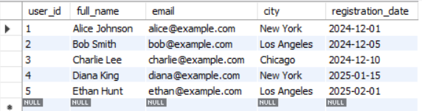

2. Events table
Create Table
CREATE TABLE Events (
event_id INT AUTO_INCREMENT PRIMARY KEY,
title VARCHAR(200) NOT NULL,
description TEXT,
city VARCHAR(100) NOT NULL,
start_date DATETIME NOT NULL,
end_date DATETIME NOT NULL,
status ENUM('upcoming','completed','cancelled'),
organizer_id INT,
FOREIGN KEY (organizer_id) REFERENCES Users(user_id)
);
Insert Sample Data
INSERT INTO Events
(event_id, title, description, city, start_date, end_date, status, organizer_id)
VALUES
(1,
'Tech Innovators Meetup',
'A meetup for tech enthusiasts.',
'New York',
'2025-06-10 10:00:00',
'2025-06-10 16:00:00',
'upcoming',
1),
(2,
'AI & ML Conference',
'Conference on AI and ML advancements.',
'Chicago',
'2025-05-15 09:00:00',
'2025-05-15 17:00:00',
'completed',
3),
(3,
'Frontend Development Bootcamp',
'Hands-on training on frontend tech.',
'Los Angeles',
'2025-07-01 10:00:00',
'2025-07-03 16:00:00',
'upcoming',
2);
Check Data
SELECT * FROM Events;
3. Sessions Table
Create Table
CREATE TABLE Sessions (
session_id INT AUTO_INCREMENT PRIMARY KEY,
event_id INT,
title VARCHAR(200) NOT NULL,
speaker_name VARCHAR(100) NOT NULL,
start_time DATETIME NOT NULL,
end_time DATETIME NOT NULL,
FOREIGN KEY (event_id) REFERENCES Events(event_id)
);
Insert Data
INSERT INTO Sessions
(session_id, event_id, title, speaker_name, start_time, end_time)
VALUES
(1,
1,
'Opening Keynote',
'Dr. Tech',
'2025-06-10 10:00:00',
'2025-06-10 11:00:00'),
(2,
1,
'Future of Web Dev',
'Alice Johnson',
'2025-06-10 11:15:00',
'2025-06-10 12:30:00'),
(3,
2,
'AI in Healthcare',
'Charlie Lee',
'2025-05-15 09:30:00',
'2025-05-15 11:00:00'),
(4,
3,
'Intro to HTML5',
'Bob Smith',
'2025-07-01 10:00:00',
'2025-07-01 12:00:00');
Verify
SELECT * FROM Sessions;
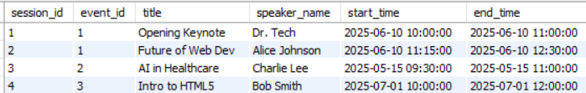
4. Registrations Table
Create Table
CREATE TABLE Registrations (
registration_id INT AUTO_INCREMENT PRIMARY KEY,
user_id INT,
event_id INT,
registration_date DATE NOT NULL,
FOREIGN KEY (user_id) REFERENCES Users(user_id),
FOREIGN KEY (event_id) REFERENCES Events(event_id)
);
Insert Data
INSERT INTO Registrations
(registration_id, user_id, event_id, registration_date)
VALUES
(1, 1, 1, '2025-05-01'),
(2, 2, 1, '2025-05-02'),
(3, 3, 2, '2025-04-30'),
(4, 4, 2, '2025-04-28'),
(5, 5, 3, '2025-06-15');
Verify
SELECT * FROM Registrations;
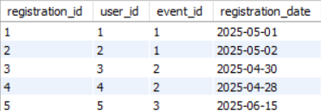
5. Feedback Table
Create Table
CREATE TABLE Feedback (
feedback_id INT AUTO_INCREMENT PRIMARY KEY,
user_id INT,
event_id INT,
rating INT CHECK (rating BETWEEN 1 AND 5),
comments TEXT,
feedback_date DATE NOT NULL,
FOREIGN KEY (user_id) REFERENCES Users(user_id),
FOREIGN KEY (event_id) REFERENCES Events(event_id)
);

Insert Data
INSERT INTO Feedback
(feedback_id, user_id, event_id, rating, comments, feedback_date)
VALUES
(1,
3,
2,
4,
'Great insights!',
'2025-05-16'),
(2,
4,
2,
5,
'Very informative.',
'2025-05-16'),
(3,
2,
1,
3,
'Could be better.',
'2025-06-11');
Verify
SELECT * FROM Feedback;
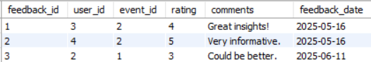
6. Resources Table
Create Table
CREATE TABLE Resources (
resource_id INT AUTO_INCREMENT PRIMARY KEY,
event_id INT,
resource_type ENUM('pdf','image','link'),
resource_url VARCHAR(255) NOT NULL,
uploaded_at DATETIME NOT NULL,
FOREIGN KEY (event_id) REFERENCES Events(event_id)
);

Insert Data
INSERT INTO Resources
(resource_id, event_id, resource_type, resource_url, uploaded_at)
VALUES
(1,
1,
'pdf',
'https://portal.com/resources/tech_meetup_agenda.pdf',
'2025-05-01 10:00:00'),
(2,
2,
'image',
'https://portal.com/resources/ai_poster.jpg',
'2025-04-20 09:00:00'),
(3,
3,
'link',
'https://portal.com/resources/html5_docs',
'2025-06-25 15:00:00');
Verify
SELECT * FROM Resources;
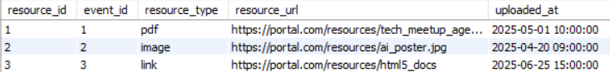
Exercise 1: User Upcoming Events
Question:
Show a list of all upcoming events a user is registered for in their city, sorted by date.
Query
SELECT
u.user_id,
u.full_name,
e.event_id,
e.title,
e.city,
e.start_date
FROM Users u
JOIN Registrations r
ON u.user_id = r.user_id
JOIN Events e
ON r.event_id = e.event_id
WHERE e.status = 'upcoming'
AND u.city = e.city
ORDER BY e.start_date;
Exercise 2: Top Rated Events
Question:
Identify events with the highest average rating, considering only those that have received at least 10 feedback submissions.
Query
SELECT
e.event_id,
e.title,
AVG(f.rating) AS average_rating,
COUNT(f.feedback_id) AS total_feedbacks
FROM Events e
JOIN Feedback f
ON e.event_id = f.event_id
GROUP BY e.event_id, e.title
HAVING COUNT(f.feedback_id) >= 10
ORDER BY average_rating DESC;
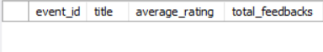
Exercise 3: Inactive Users
Question:
Retrieve users who have not registered for any events in the last 90 days.
Query
SELECT u.user_id,
u.full_name,
u.email,
u.city
FROM Users u
WHERE u.user_id NOT IN (
SELECT DISTINCT r.user_id
FROM Registrations r
WHERE r.registration_date >= CURDATE() - INTERVAL 90 DAY
);
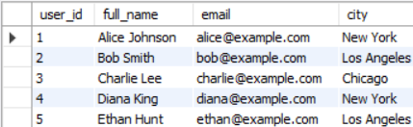
Exercise 4: Peak Session Hours
Question:
Count how many sessions are scheduled between 10 AM and 12 PM for each event.
Query
SELECT e.event_id,
e.title,
COUNT(
CASE
WHEN TIME(s.start_time) BETWEEN '10:00:00' AND '12:00:00'
THEN 1
END
) AS session_count
FROM Events e
LEFT JOIN Sessions s
ON e.event_id = s.event_id
GROUP BY e.event_id, e.title;
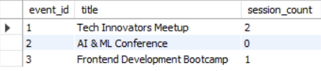
Exercise 5: Most Active Cities
Question:
List the top 5 cities with the highest number of distinct user registrations.
Query
SELECT u.city,
COUNT(DISTINCT r.user_id) AS total_registrations
FROM Users u
JOIN Registrations r
ON u.user_id = r.user_id
GROUP BY u.city
ORDER BY total_registrations DESC
LIMIT 5;
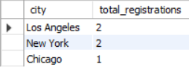
Exercise 6: Event Resource Summary
Question:
Generate a report showing the number of resources (PDFs, Images, Links) uploaded for each event.
Query
SELECT e.event_id,
e.title,
COUNT(r.resource_id) AS total_resources
FROM Events e
LEFT JOIN Resources r
ON e.event_id = r.event_id
GROUP BY e.event_id, e.title;
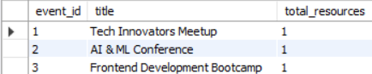
Exercise 7: Low Feedback Alerts
Question:
List all users who gave feedback with a rating less than 3, along with their comments and associated event names.
Query
SELECT u.full_name,
f.comments,
e.title AS event_name
FROM Feedback f
JOIN Users u
ON f.user_id = u.user_id
JOIN Events e
ON f.event_id = e.event_id
WHERE f.rating < 3;
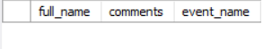

Exercise 8: Sessions per Upcoming Event
Question:
Display all upcoming events with the count of sessions scheduled for them.
Query
SELECT e.event_id,
e.title,
COUNT(s.session_id) AS session_count
FROM Events e
LEFT JOIN Sessions s
ON e.event_id = s.event_id
WHERE e.status = 'upcoming'
GROUP BY e.event_id, e.title;
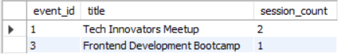
Exercise 9: Organizer Event Summary
Question:
For each event organizer, show the number of events created and their current status (upcoming, completed, cancelled).
Query
SELECT u.user_id,
u.full_name,
e.status,
COUNT(e.event_id) AS total_events
FROM Users u
JOIN Events e
ON u.user_id = e.organizer_id
GROUP BY u.user_id, u.full_name, e.status;
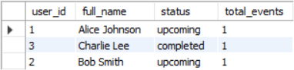
Exercise 10: Feedback Gap
Question:
Identify events that had registrations but received no feedback at all.
Query
SELECT e.event_id,
e.title
FROM Events e
JOIN Registrations r
ON e.event_id = r.event_id
LEFT JOIN Feedback f
ON e.event_id = f.event_id
WHERE f.feedback_id IS NULL
GROUP BY e.event_id, e.title;
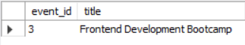
Exercise 11: Daily New User Count
Question:
Find the number of users who registered each day in the last 7 days.
Query
SELECT registration_date,
COUNT(*) AS user_count
FROM Users
WHERE registration_date >= CURDATE() - INTERVAL 7 DAY
GROUP BY registration_date
ORDER BY registration_date;
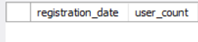
Exercise 12: Event with Maximum Sessions
Question:
List the event(s) with the highest number of sessions.
Query
SELECT e.event_id,
e.title,
COUNT(s.session_id) AS total_sessions
FROM Events e
JOIN Sessions s
ON e.event_id = s.event_id
GROUP BY e.event_id, e.title
HAVING COUNT(s.session_id) = (
SELECT MAX(session_count)
FROM (
SELECT COUNT(*) AS session_count
FROM Sessions
GROUP BY event_id
) AS temp
);
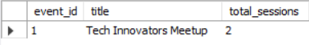
Exercise 13: Average Rating per City
Question:
Calculate the average feedback rating of events conducted in each city.
Query
SELECT e.city,
AVG(f.rating) AS average_rating
FROM Events e
JOIN Feedback f
ON e.event_id = f.event_id
GROUP BY e.city;
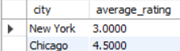
Exercise 14: Most Registered Events
Question:
List the top 3 events based on the total number of user registrations.
Query
SELECT e.event_id,
e.title,
COUNT(r.registration_id) AS total_registrations
FROM Events e
JOIN Registrations r
ON e.event_id = r.event_id
GROUP BY e.event_id, e.title
ORDER BY total_registrations DESC
LIMIT 3;
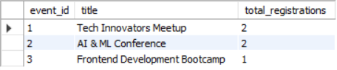
Exercise 15: Event Session Time Conflict
Question:
Identify overlapping sessions within the same event (i.e., session start and end times that conflict).
Query
SELECT s1.event_id,
s1.title AS session1,
s2.title AS session2,
s1.start_time,
s1.end_time,
s2.start_time,
s2.end_time
FROM Sessions s1
JOIN Sessions s2
ON s1.event_id = s2.event_id
AND s1.session_id < s2.session_id
AND s1.start_time < s2.end_time
AND s1.end_time > s2.start_time;
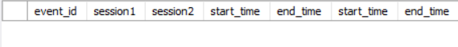
Exercise 16: Unregistered Active Users
Question:
Find users who created an account in the last 30 days but haven’t registered for any events.
Query
SELECT u.user_id,
u.full_name,
u.email,
u.registration_date
FROM Users u
LEFT JOIN Registrations r
ON u.user_id = r.user_id
WHERE u.registration_date >= CURDATE() - INTERVAL 30 DAY
AND r.registration_id IS NULL;
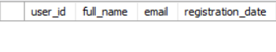
Exercise 17: Multi-Session Speakers
Question:
Identify speakers who are handling more than one session across all events.
Query
SELECT speaker_name,
COUNT(session_id) AS total_sessions
FROM Sessions
GROUP BY speaker_name
HAVING COUNT(session_id) > 1;
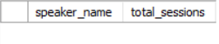
Exercise 18: Resource Availability Check
Question:
List all events that do not have any resources uploaded.
Query
SELECT e.event_id,
e.title
FROM Events e
LEFT JOIN Resources r
ON e.event_id = r.event_id
WHERE r.resource_id IS NULL;

Exercise 19: Completed Events with Feedback Summary
Question:
For completed events, show total registrations and average feedback rating.
Query
SELECT e.event_id,
e.title,
COUNT(DISTINCT r.registration_id) AS total_registrations,
AVG(f.rating) AS average_rating
FROM Events e
LEFT JOIN Registrations r
ON e.event_id = r.event_id
LEFT JOIN Feedback f
ON e.event_id = f.event_id
WHERE e.status = 'completed'
GROUP BY e.event_id, e.title;
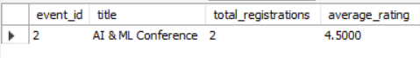
Exercise 20: User Engagement Index
Question:
For each user, calculate how many events they attended and how many feedbacks they submitted.
Query
SELECT u.user_id,
u.full_name,
COUNT(DISTINCT r.event_id) AS events_attended,
COUNT(DISTINCT f.feedback_id) AS feedbacks_submitted
FROM Users u
LEFT JOIN Registrations r
ON u.user_id = r.user_id
LEFT JOIN Feedback f
ON u.user_id = f.user_id
GROUP BY u.user_id, u.full_name;
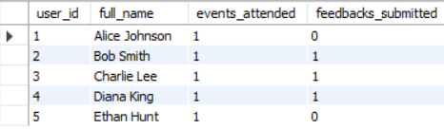
Exercise 21: Top Feedback Providers
Question:
List top 5 users who have submitted the most feedback entries.
Query
SELECT u.user_id,
u.full_name,
COUNT(f.feedback_id) AS total_feedbacks
FROM Users u
JOIN Feedback f
ON u.user_id = f.user_id
GROUP BY u.user_id, u.full_name
ORDER BY total_feedbacks DESC
LIMIT 5;
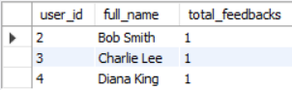
Exercise 22: Duplicate Registrations Check
Question:
Detect if a user has been registered more than once for the same event.
Query
SELECT user_id,
event_id,
COUNT(*) AS registration_count
FROM Registrations
GROUP BY user_id, event_id
HAVING COUNT(*) > 1;
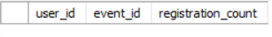

Exercise 23: Registration Trends
Question:
Show a month-wise registration count trend over the past 12 months.
Query
SELECT DATE_FORMAT(registration_date, '%Y-%m') AS month,
COUNT(*) AS registration_count
FROM Registrations
WHERE registration_date >= CURDATE() - INTERVAL 12 MONTH
GROUP BY DATE_FORMAT(registration_date, '%Y-%m')
ORDER BY month;
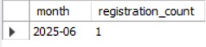
Exercise 24: Average Session Duration per Event
Question:
Compute the average duration (in minutes) of sessions in each event.
Query
SELECT e.event_id,
e.title,
AVG(TIMESTAMPDIFF(MINUTE,
s.start_time,
s.end_time)) AS avg_duration_minutes
FROM Events e
JOIN Sessions s
ON e.event_id = s.event_id
GROUP BY e.event_id, e.title;
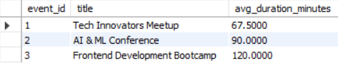
Exercise 25: Events Without Sessions
Question:
List all events that currently have no sessions scheduled under them.

Query
SELECT e.event_id,
e.title
FROM Events e
LEFT JOIN Sessions s
ON e.event_id = s.event_id
WHERE s.session_id IS NULL;



